- List titles of all movies released in 2008
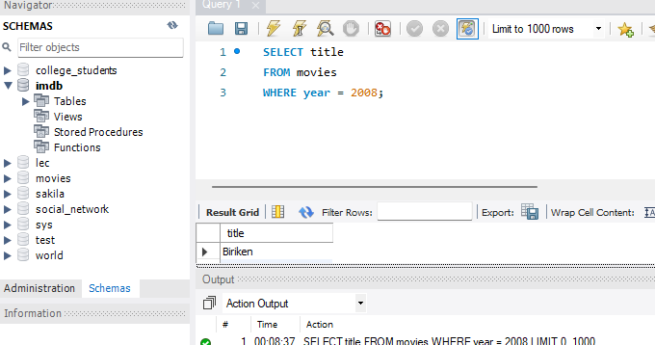
- Determine the birth year of Emma Stone
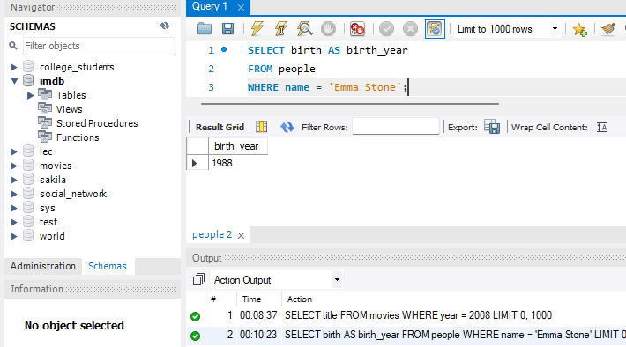
- List titles of all movies with a release date on or after 2018, in alphabetical order.
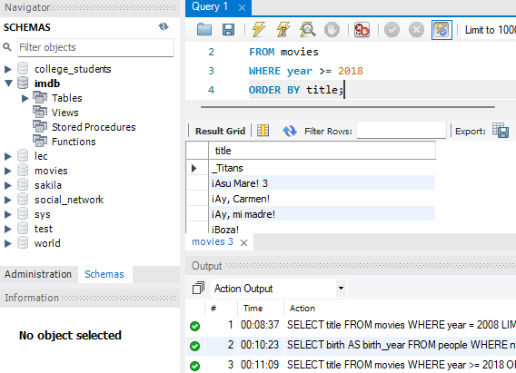

- List titles and release years of all Harry Potter movies, in chronological order
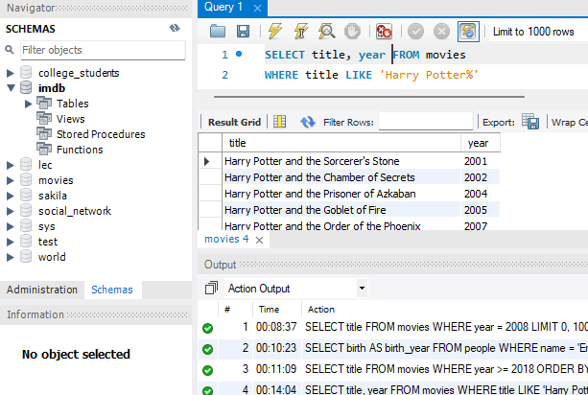

- Determine the number of movies with an IMDb rating of 10.0
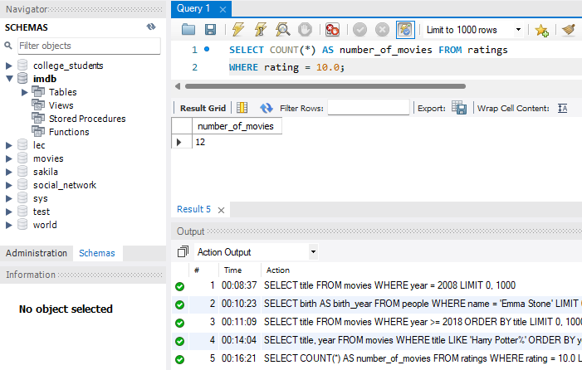
- Determine the average rating of all movies released in 2012
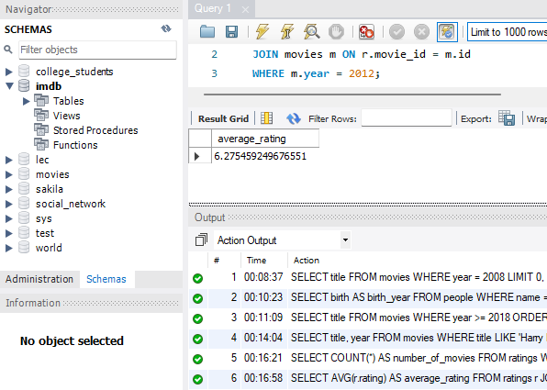

- List all movies released in 2010 and their ratings, in descending order by rating
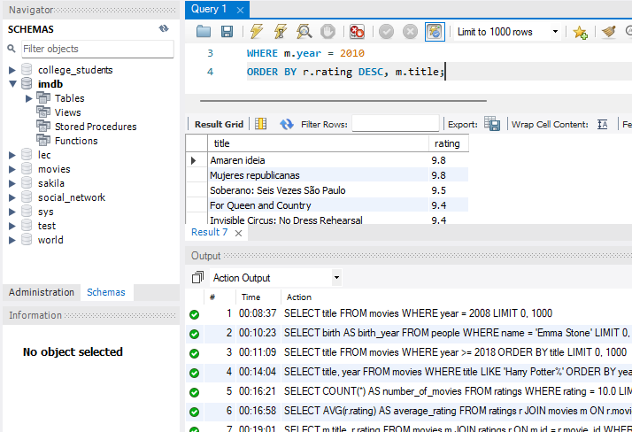
- List the names of all people who starred in Toy Story
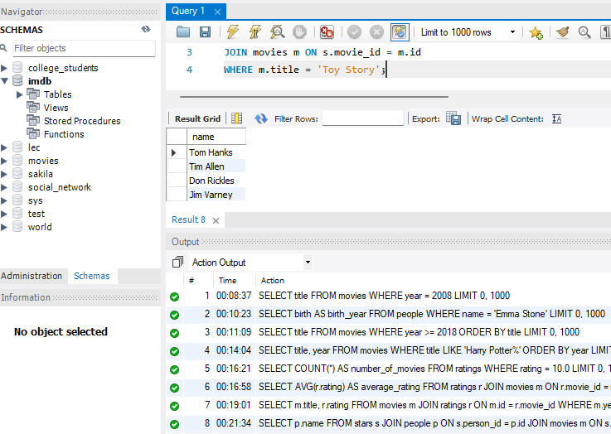

- List the names of all people who starred in a movie released in 2004, ordered by birth year
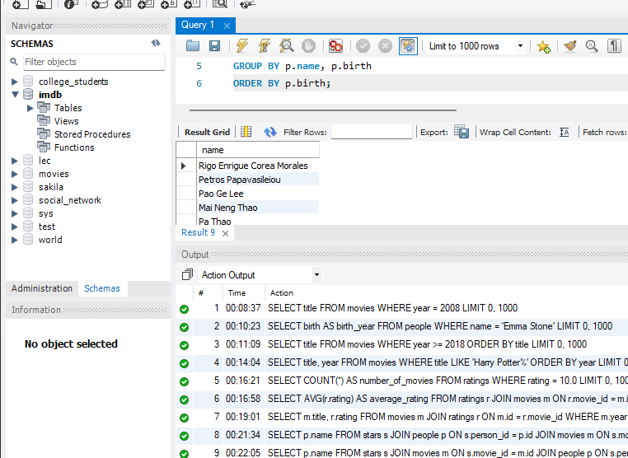

- List the names of all people who have directed a movie that received a rating of at least 9.0
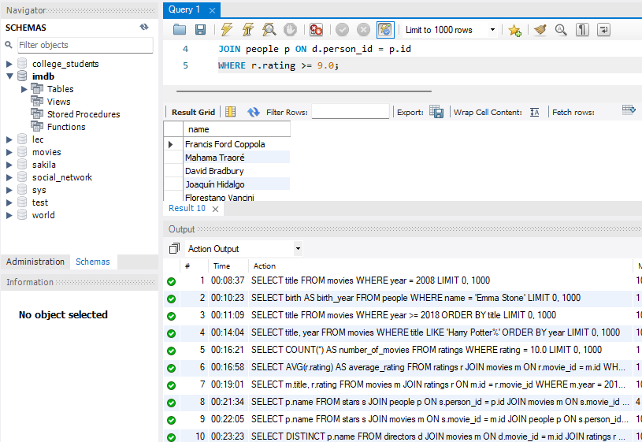
- List the titles of the five highest rated movies that Chadwick Boseman starred in
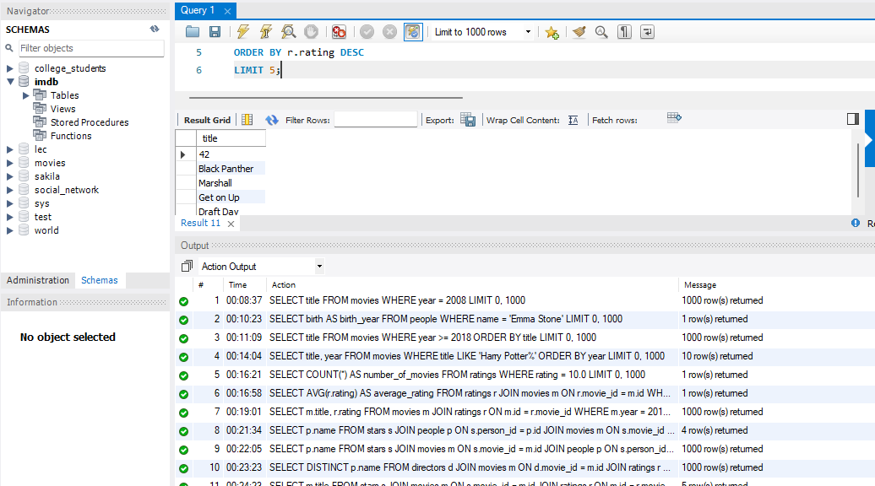
- List the titles of all movies in which both Johnny Depp and Helena Bonham Carter starred
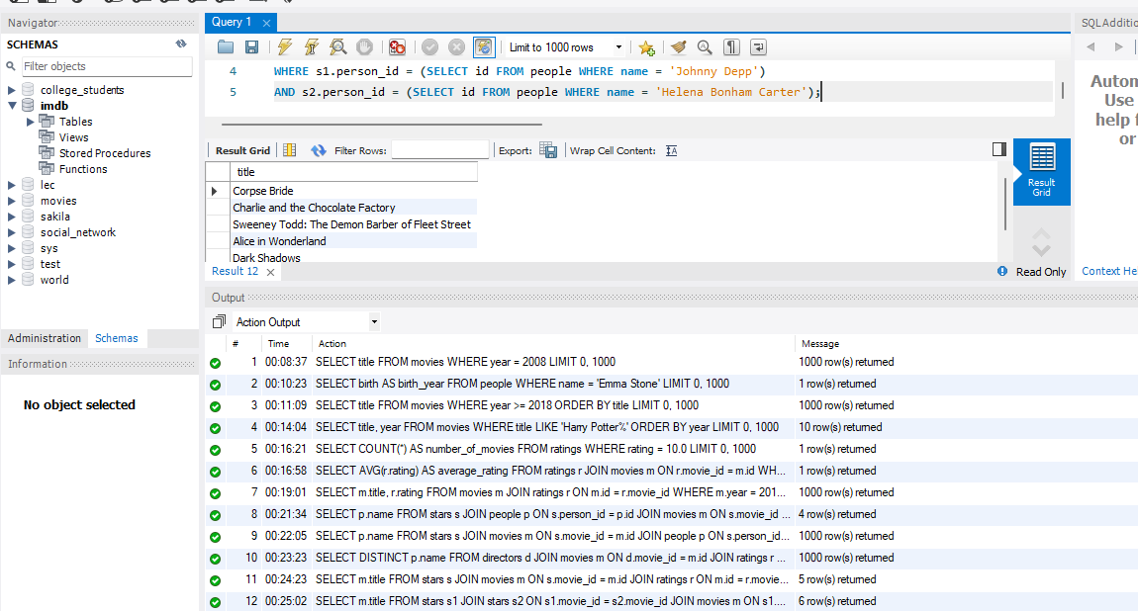

- List the names of all people who starred in a movie in which Kevin Bacon also starred (excluding Kevin Bacon)
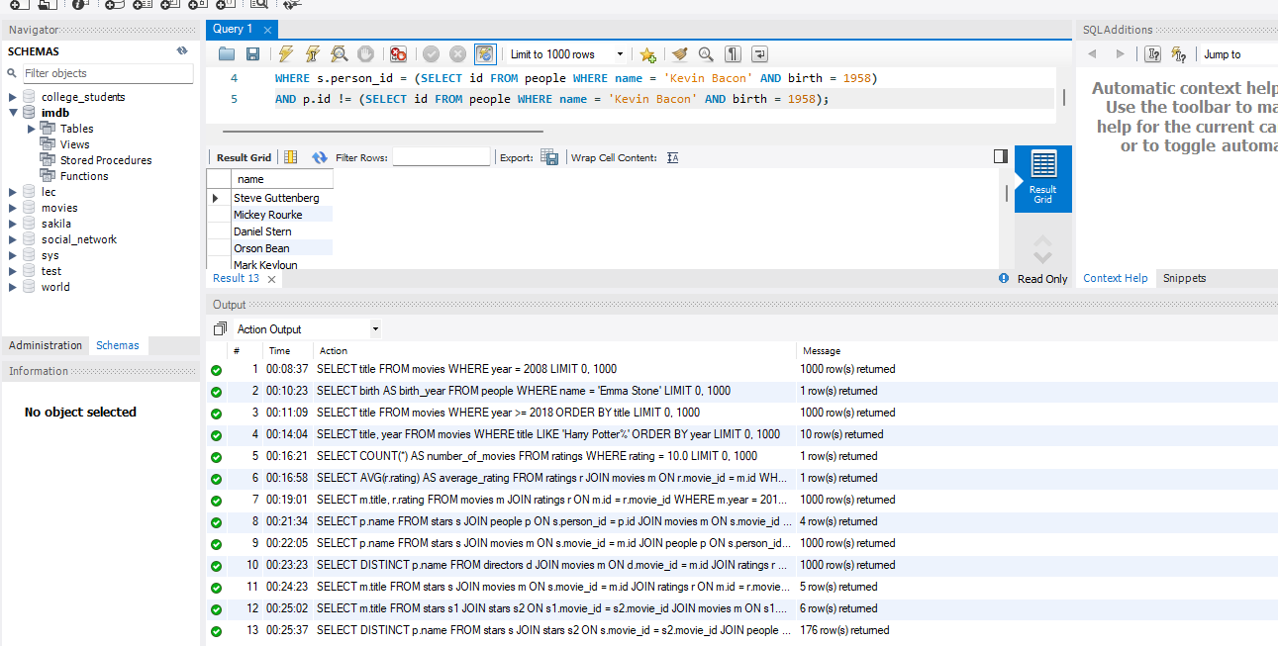
- Find all the movies that are better than the average ratings
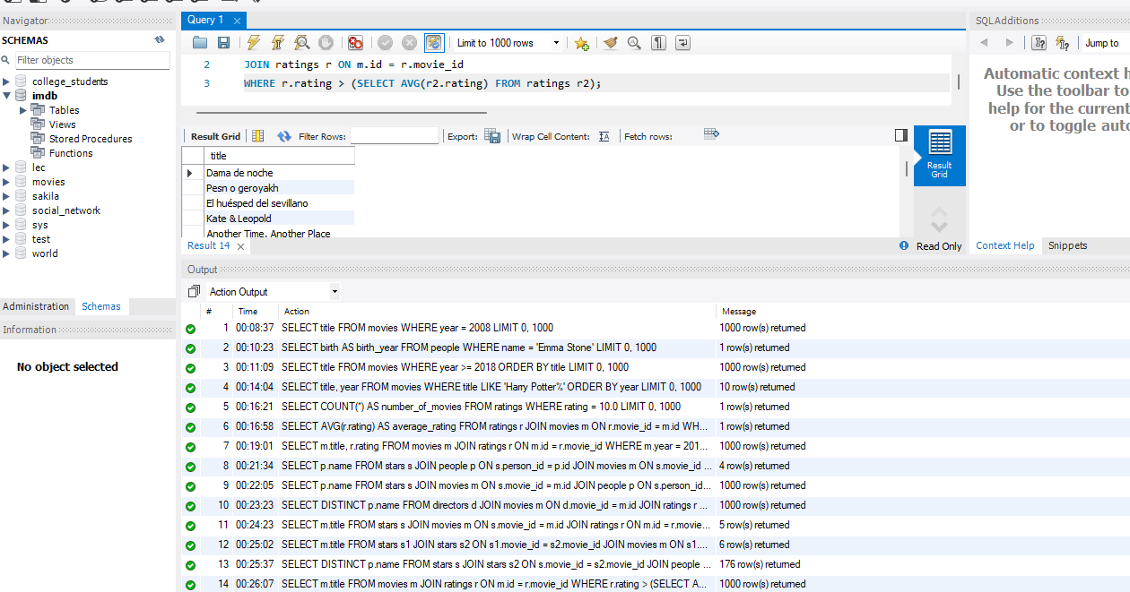
- Find the average rating for each co-star
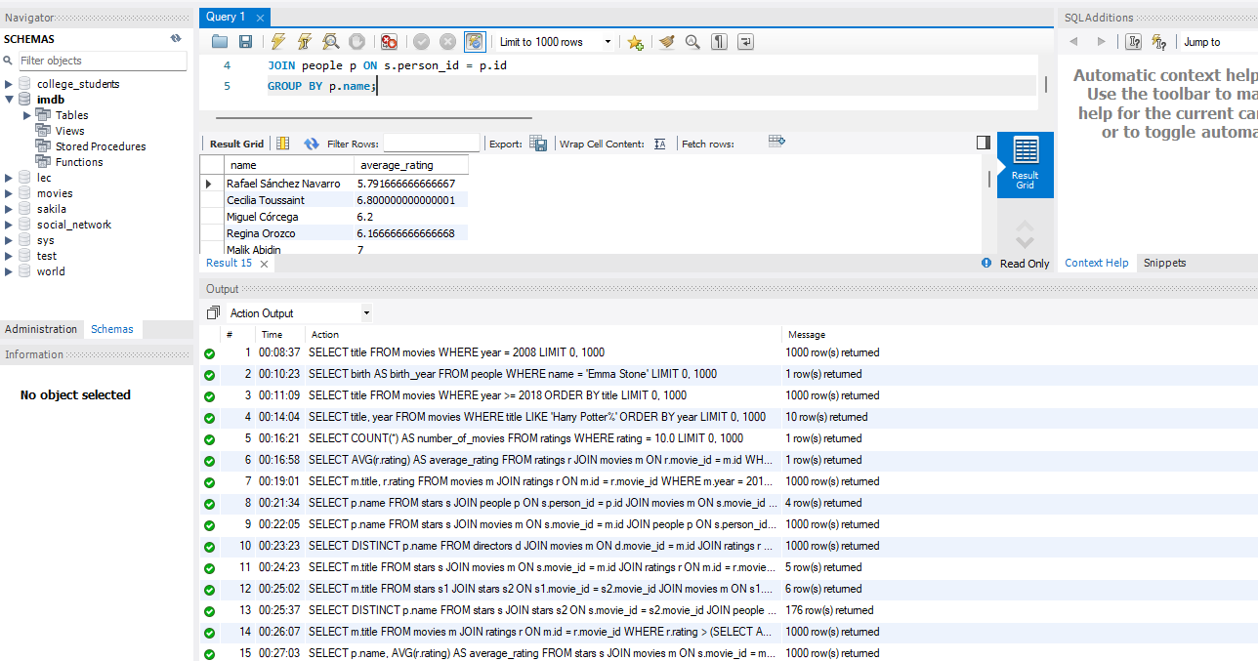

- Return the highest and the lowest rated movies for each actor, sort by the difference in ratings
